**PRIMARY TWO LESSON NOTES TERM II 2024**

**LESSON 1**

Vocabulary about things we make.

* crafts
* materials
* local
* things
* hands
* balls
* dolls
* mats
* chairs
* tables
* pots
* baskets
* bags
* ropes
* palm leaves
* sisal
* banana fibres
* raffia
* wood
* bead

**Activity**

1. Fill in the missing letters

cr__fts

l__c__l

m__t__rials

b__ll

1. Write these words correctly

ftscra ________________

ffiara ________________

rialsmate ________________

gab ____________________

pero ___________________

1. Write short words from a long word.

material ______________________

hand ___________________________

palm leaves ______________________

basket __________________________

1. Name these crafts.

|  |  |  |
| --- | --- | --- |
| C:\Users\jhon\Desktop\SCI DIgrams\PICTURES\ballw.bmpC:\Users\jhon\Desktop\SCI DIgrams\PICTURES\ballw.bmp  C:\Users\jhon\Desktop\SCI DIgrams\PICTURES\ballw.bmp |  |  |
|  |  |  |

**LESSON 2.**

**Crafts**

Crafts are things we make from local materials using our hands.

Examples of things we make

* chairs
* tables
* benches
* cupboards
* balls
* dolls
* mats
* stools
* ropes
* baskets
* pots
* bags
* hats
* drum
* shoes
* earrings
* necklaces
* brooms
* carpets
* doormats
* sweaters
* flower vases
* scarves
* sandals
* mortor
* pestle
* mingling sticks
* jiko

**Activity:**

1. what are crafts?

____________________________________________________________________

1. Name any three examples of things we make.
2. __________________________________________________________________
3. __________________________________________________________________
4. __________________________________________________________________
5. Draw and name any four things we make.

|  |  |  |  |
| --- | --- | --- | --- |
|  |  |  |  |
|  |  |  |  |

1. Mention any two examples of craft found in;
2. The bedroom ________________________ ___________________
3. The sitting room ____________________ ___________________
4. The kitchen ____________________ ___________________
5. Write these words correctly

ndsha ________________________

Allsb ________________________

Sketba ________________________

1. Write out only the crafts.

baskets teachers chairs bursars ropes dolls cook

**LESSON 3**

**Structures about things we make**

Answer correctly

 What is this?

_______________________________________________________



Is this a rope?

_____________________________________________________

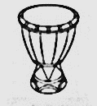 ___________________________________

Is this a pot?

____________________________________________________

What are they?

_______________________________________________________________

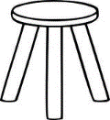 

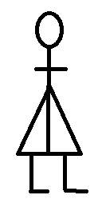 

What are those?

_______________________________________________________________

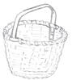

Are these baskets?

_______________________________________________________________

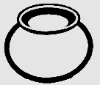

Are these chairs?

_______________________________________________________________

____

**LESSON 4.**

* Practical lesson on materials and their sources.

Examples of local materials and their sources for making crafts.

**Material Source**

* palm leaves - palm tree
* banana fibres/stalk - banana plant
* clay - swamp
* sisal - sisal plant
* raffia - palm tree
* papyrus - swamp

**LESSON 5.**

**Things we make out of different materials**

1. Banana fibres - balls, dolls, ropes, baskets, hats, mats
2. Palm leaves - mats, hats, bags, baskets, money purses
3. Clay - pots, cups, plates, flower vases
4. Wood/timber - chairs, tables, doors, cupboard, stools
5. Sticks - stools, brooms
6. Sisal - ropes, sisal bags, sacks, doormats
7. Raffia - raffia skirts
8. Threads - sweaters, scarves, socks
9. Beads - necklaces, bangles, earrings
10. Animal skins/hides - drums, shoes, belts, bags, wallets, jackets
11. Papyrus - mats, carpets
12. Grass - brooms
13. Straws - bags, mats

**Activity:**

1. Fill in the missing letters

cl__y

s__sal

w__ __d

raff__a

1. Draw and name four things we make from banana fibres

|  |  |  |  |
| --- | --- | --- | --- |
|  |  |  |  |
|  |  |  |  |

1. List down any two things we make from;

palm leaves: _______________________ ___________________

clay: _______________________ ________________________

1. Write the materials we use to make these crafts



______________________________________________



______________________________________________

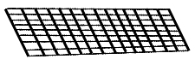

______________________________________________

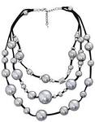

______________________________________________

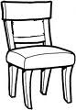

______________________________________________

**LESSON 6.**

**Guided composition about things we make**

Write the correct word to complete the story.

At time, grandmother makes   __________________ from banana stalks.

She also weaves 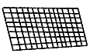  ________________ from palm leaves.

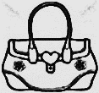One day, she bought a piece of black cloth and beads and made a very beautiful _______________. She can also use beads and palm_________________ to design money purses.

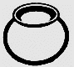Aunt Linda goes to the ___________________ every Sunday to collect clay. She teaches the young ones to model and   ______________________.

Mr. Mushoki gets wood from the forest and makes 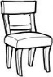  and 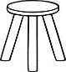  _______________________.

(bag, cups, swamp, leaves, mats, pots, chairs, stools, baskets)

**LESSON 7.**

**Uses of things we make/crafts.**

**Pots.**

* For keeping in water
* For cooking from
* For fetching water

**Mats, chairs, stools**

* For sitting on
* We sell and get money

**bricks**

* For building

**threads**

* For sewing clothes

**balls, dolls, ropes**

* For playing with

**ornaments**

* For decorating the body

**hats, sweater, socks**

* For wearing

Mortor – For pounding from

pestle – For pounding

some crafts help us to know our culture.

Some crafts are used for decoration

Some are used for dancing

**Activity:**

**Why do we make these crafts?**

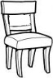

____________________________________



____________________________________

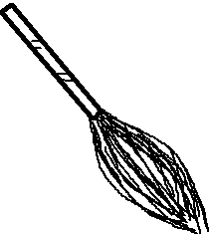

____________________________________



____________________________________

skins/hides - animals

threads/straw - factory

wood/timber - forest

seeds - garden/bush

beads - factory

needle - factory

mud - soil and water

bricks - swamp

**Activity:**

1. Fill in the missing letters

s__ ___mp

f__ r___st

fact___ry

c__ ___y

p__lmle__ves

1. What do we get from these sources?

Banana plants _______________________

Sisal plant ____________________________

Swamp ____________________________

Palm tree ____________________________

1. Match materials to their sources.

**A B**

timber sisal plant

clay palm tree

palm leaves forest

sisal swamp

1. Complete the sentences correctly.
2. Banana fibre is to banana plant as clay is to ________________________.
3. Palm leaves is to _______________________ as timber is to forest.
4. Write the materials used to make the following crafts



_______________________________

 ________________________________

______________________________



1. Give the use of plant.

_____________________________________________________________________

1. Study the picture and answer the questions

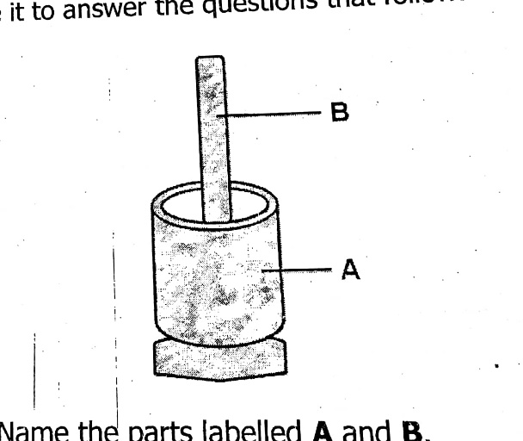

Name the crafts

1. _____________________
2. _____________________
3. Give the use of;

craft a. ________________________

craft b. ________________________

1. How are crafts important to us? Give two ways
2. ___________________________________________________________________
3. ___________________________________________________________________

**LESSON 8.**

**Jumbled sentences about things we make**

Re-arrange the given sentences to make a good story

1. Then she cut them into small strips.
2. Mummy wanted to make a basket.
3. And dried them
4. After she made a nice basket with dried banana stalks and banana fibres.
5. She went to a banana plantation to get banana stalks.

**Good story**

1. __________________________________________________________________
2. __________________________________________________________________
3. __________________________________________________________________
4. __________________________________________________________________
5. __________________________________________________________________

**LESSON 9.**

**Riddles about things we make.**

Read the riddles carefully and give a correct answer.

1. I am an example of crafts. I am made out of palm leaves or banana fibres. People sit on me.

What am I?

____________________________________________________________________

1. I am mad out banana fibres. I have a head, hands and legs. Girls to play with me. What am I?

____________________________________________________________________

1. I am a material used to make crafts. I am got from swamps. They use me to make pots, flower vases, cups, plates. What am I?

____________________________________________________________________

1. I am made out of sisal. You use me for skipping. What am I?

____________________________________________________________________

**LESSON 10.**

**Passage about Mrs Budongo’s craft shop**

Read the passage below and answer the questions that follow in full sentences.

**Mrs. Budondo’s craft shop**

On Sunday morning, Brenda and her mother went out for shopping. As they moved along streets, they looked at different items and admired them.

Lastly, they entered into Mrs. Budondo’s craft shop. In this shop many crafts were displayed for sale and looked so beautiful. Most of them were made using hands and well painted. Examples of crafts in Mrs. Budondo’s craft shop were baskets, dolls, toy cars, ladles, bangles, necklaces, pots and flower vases, door mats, carpets, tablemats, door mats and a table mat. Her mother paid for them and left the shop happily.

**Questions:**

1. Whose craft shop is mentioned in the passage above?

____________________________________________________________________

1. When did Brenda and her mother go for shopping?

____________________________________________________________________

1. Who went for shopping?

____________________________________________________________________

1. Write four examples of crafts in Mrs. Budondo’s craft shop
2. ___________________________________________________________________
3. ___________________________________________________________________
4. ___________________________________________________________________
5. What was Brenda interested in?

____________________________________________________________________

1. Who paid for Brenda’s crafts?

____________________________________________________________________

**LESSON 11**

**People who make crafts.**

Different people make different crafts.

Crafts men

Potters

Welders

Blacksmith

Tailors

Carpenters

Builders

Craft men - make things out of local materials

Welders - make things from metals.

Blacksmith - makes things out of iron.

Carpenters - make things from wood.

Potters - makes pots

Tailor - make clothes from treads using a sewing

machine and needle.

**Ways of making crafts**

* By weaking
* By modelling
* By knitting
* By sewing
* By tie and dye

**By knitting**

* Sweaters
* Scarves

**By weaving**

* Baskets
* Mats

**By modelling**

* Pots
* Cups
* Plates

**By tie and dye**

* Bitenge

**Activity:**

1. Who is a potter?

___________________________________________________________________

1. What does a welder use to make things?

____________________________________________________________________

1. Who uses a sewing machine and needle to make clothes?

____________________________________________________________________

1. Mention three ways of making crafts.

____________________________________________________________________

1. How do we make these crafts?

____________________________________



__________________________________



____________________________________

**LESSON 12.**

**Letter sound “sp”**

Syllables with sound “sp”

spee spoo spa spe spi spo spu spou spoi spai

**Form correct words.**

spee___d = ____________________

spoo__n =_____________________

spa__nner = __________________

spu__r = _______________________

spi__ll = ______________________

spo__il =______________________

spo__nge = __________________

spo__rt = ___________________

spe__cial= __________________

spo___t = _________________

From the sentences below, write out words with letter sound “sp”

1. I use a spoon when eating porridge ______________________________
2. Speeding causes accidents. ______________________________________
3. I bathe with a sponge. __________________________________________
4. A mechanic uses a spanner when repairing cars.

_________________________________________________________________

1. Breast milk is a special food for babies.

_________________________________________________________________

**LESSON 13.**

A rhyme about Ding dong bell.

Ding dong bell, Ding dong bell, Pussy is in the well, pussy is in the well. Who put her in? who put her in little Johnny thin, little Johnny thin, who pulled her out? Who pulled her out? Little Tonny shout, little Tonny shout.

What a naughty boy little Johnny was! To drown the little innocent pussy cat. Who never did any harm to people at home who never did any harm to people at home! But killed all the mice.

**Answer the questions in full sentences.**

1. Which animal dry in the well?

____________________________________________________________________

1. Is the animal dry in the wet?

____________________________________________________________________

1. Who put pussy in the well?

____________________________________________________________________

1. What did little Tonny shout do?

____________________________________________________________________

1. What kind of person was little John thin?

____________________________________________________________________

1. Is pussy domestic or wild?

____________________________________________________________________

**END**

**LESSON 1**

**TRANSPORT**

**Vocabulary**

transport

train

goods

canoe

pedestrian

driver

car

donkey

air

ship

yacht

cyclist

water

bicycle

camel

movement

captain

pilot

railway

motorcycle

road

horse

ferry

another

rider

**Activity**

1. Fill in the missing letters.

l__rry

d__nk__y

m__t__rcyle

tr___nsp__rt

1. Write these words correctly

atbo______________

keydon _________________

cyclemotor _________________

cybicle __________________

1. Write correct or wrong
2. I come to school by a train
3. Some people move from one place to another on a horse
4. A boat moves on water

**LESSON 2**

**Definition of transport**

Transport is the movement of people or goods from one place to another.

**Types of transport**

There are four types of transport

* Road transport
* Air transport
* Water transport
* Railway transport

**Means of road transport**

Road transport is the commonest type of transport

The means of road transport are;

* buses
* taxis
* lorries
* motorcycles
* bicycles
* trailers
* camels
* donkeys
* horses

**Activity**

1. Listen and write these words
2. people
3. goods
4. place
5. movement
6. transport
7. The movement of people or goods from one place to another is called ________________________________.
8. Give the four types of transport.

_________________________ ___________________________

_________________________ ___________________________

1. Draw these means of road transport.

|  |  |  |  |  |  |  |
| --- | --- | --- | --- | --- | --- | --- |
|  |  |  |  |  |  |  |
| bus | train | car | lorry | train | bicycle | donkey |

**LESSON 3.**

**Means of air transport**

Air transport is the quickest type of transport.

The means are;

aeroplane

helicopter

parachute

air ballon

rocket

jet

**Means of water transport**

Water transport is the slowest type of transport.

The means are;

* yacht
* canoe
* boat
* ship
* ferry
* submarine

**Means of railway transport**

Railway transport is the cheapest type of transport.

The means are;

* train
* tram

**Activity:**

1. Write out means of water transport from the list.

canoe, bus, ship, lorry, yacht

boat, train, taxi, ferry

aeroplane

1. Answer correctly
2. I come to school by ___________________________________________
3. A ___________________ moves on water.
4. The ______________________ carry goods from one place to another.
5. Arrange the letters and make correct words.

planeaero - __________________

copterheli - __________________

cutepara - ___________________

cketro - ______________________

amtr - _______________________

1. Write any two means of;
2. road transport - ______________________ __________________
3. air transport - _____________________ __________________

**LESSON 4.**

**Sound “tr”**

Syllables of sound “tr”

tra tre tri tro tru trea tree troo

Words with sound “tra”

trap, trend, trip, train, transport, trumpet, trade, tramble, tram, tractor, truck, tree, trench, stretch, strain, traight, travel, triple, trust

**Activity:**

1. Form words

tra__p - ____________________

tra___c___tor - _________________

tri__p - _____________________

tra___vel - ___________________

tru__st - ___________________

tra__de - ____________________

tru__ck - ____________________

tri__m - _____________________

tri___ck - ____________________

tra__ns__port - ___________________

tra__ffic - _____________________

1. Form correct words

ust

tr unk

affic

1. Construct meaningful sentences using these words.
2. tractor ___________________________
3. trip ______________________________
4. trust ____________________________
5. train ___________________________

**LESSON 5**

People who operate different means of transport.

**Means people**

car driver

aeroplane pilot

train/tram captain

boat sailor

bicycle cyclist

horse/donkey rider

ship ship captain

motorcycle cyclist

**Places where we find different means of transport**

boat/ship/ferry - harbor port/landing site

train - railway station

motorcycle - stage

taxi - taxi park

bicycle - stage

aeroplane - airport

**Activity:**

1. Who operates the following means of transport?
2. bus ______________________
3. aeroplane ____________________
4. train ________________________
5. boat ________________________
6. motorcycle __________________
7. What means of transport do we find in these places?
8. stage _______________________
9. harbor _______________________
10. railway _______________________
11. airport _______________________

**LESSON 6.**

Answering riddles related to transport

1. I am a mean of transport who moves on water. What am I?

_____________________________________________________________________

1. I am an important person. I operate the aeroplane. Who am I?

_____________________________________________________________________

1. I am an important person. I move buses and cars on the road. Who am I?

_____________________________________________________________________

1. I am a mean of transport. I am very cheap. I move on a rail. Who am I?

_____________________________________________________________________

1. I have four legs. I transport people. I move on the road. I am a living thing. Who am I?

_____________________________________________________________________

**LESSON 7.**

**Uses of transport**

* For carrying people
* For carrying food
* For carrying animals
* For carrying charcoal
* For carrying firewood
* For carrying building materials
* For carrying water.

**People who use the road.**

* pedestrians
* passengers
* driver
* rider
* cyclists

**Pedestrians**

pedestrians are people who walk along the road.

**Activity:**

1. What is transport?

____________________________________________________________________

1. Write out uses of transport from the list.

carrying people

sleeping ________________________

carrying food ________________________

carrying water ________________________

carrying animals ________________________

eating

1. Complete the table correctly

|  |  |
| --- | --- |
| Types of transport |  |
| 1. quickest type 2. commonest type 3. most expensive type | __________________________  __________________________  __________________________ |

1. Match people to the means they operate.

train pilot

boat cyclist

aeroplane captain

bicycle sailor

**LESSON 8.**

A passage “A busy town”

Read the story and use it to answer the questions in full.

**A BUSY TOWN**

Our town is Mukono. It is a very busy town. There are shops, markets, hospital a and clinics with very many people moving up and down. Some people sell things, drive small and big vehicles, carry luggage from one lorry to another. Here are people who sell raw and cooked food everywhere. In Mukono taxi park, you hear all sorts of noise. Men shout calling people different stages. There are women who carry baskets of fruits on their heads from one taxi park to another. There are those who sell tea in big kettles and those that sell brooms that they carry one heads. I love going to our town and enjoy the nature of people who work.

**Questions:**

1. What is the name of the town?

____________________________________________________________________

1. List all the jobs that people in this town do.

__________________________ __________________________________

_________________________ __________________________________

1. Where do people in this town go for treatment?

____________________________________________________________________

1. How do we call a place where taxis are found?

____________________________________________________________________

1. Why do men shout in the taxi park?

____________________________________________________________________

1. How do women carry fruits?

____________________________________________________________________

1. Is tea sold from small kettles?

____________________________________________________________________

1. Write the past tense for;
2. hear - __________________
3. carry - __________________
4. go - _______________

**LESSON 9.**

**Safe ways of using the word**

* Walk in groups.
* Walk in a straight line.
* Follow traffic lights.
* Cross from a zebra crossing.
* Walk at the side of the road.
* When crossing the road, look left, look right, look left again, if the road is clear, cross but do not run.

**Unsafe ways of using the road**

* Playing on the road.
* Crossing the road carelessly
* Not following road signs
* Throwing objects on moving vehicles.
* Walking in the middle of the road.

**Activity:**

1. What are road signs?

___________________________________________________________________

1. Write any four unsafe ways of using the road.

_________________________ __________________________________

_________________________ __________________________________

**LESSON 10.**

**Road signs**

Road signs are the things that guide us on the road.

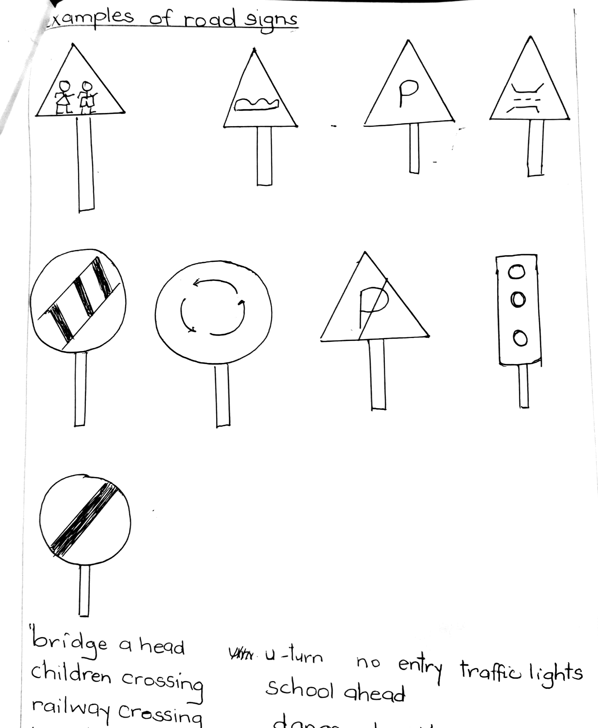

bridge a head

children crossing

railway crossing

round about

men at work

church a head

parking

zebra crossing

u-turn no entry traffic lights

school a head

danger ahead/accident ahead

humps ahead

**Activity:**

1. What are road signs?

___________________________________________________________________

1. Underline the safe ways of using the road
2. Following traffic lights.
3. Playing in the road
4. Crossing from a zebra crossing
5. Fighting in the road
6. Walking in single line.
7. Name these colours on the traffic lights.

A _______________

B _______________

C ________________

1. What do these traffic lights means.
2. Red __________________________
3. Orange ______________________
4. Green _______________________
5. What are the unsafe ways when crossing the road? (Give three of them)

____________________________________________________________________________________________________________________________________________________________________________________________________________

**LESSON 11.**

**Picture composition “Traffic lights”**

Study the picture below and answer the questions correctly

A ________________

B ________________

C ________________

1. Who uses the traffic lights?

____________________________________________________________________

1. Write the colours of the traffic lights in order.

____________________________________________________________________

1. Which light tells drivers to go?

____________________________________________________________________

1. Where do we usually find traffic lights?

____________________________________________________________________

1. Draw a zebra crossing

**LESSON 12.**

|  |  |  |  |  |  |
| --- | --- | --- | --- | --- | --- |
| **Theme** | **Lesson** | **Methods** | **Practical activities** | **Life skills & values** | **Materials** |
| Our transport | Letter sound “fl” | * Phonic method * Syllabic method * Audio visual approach | * Watching videos with sound “fl” * Using letter cards to form * Syllables and words | * fluency * accurancy * critical thinking | * television * letter cards |

**Letter sound “fl”**

Syllables with sound “fl”

fla fle fli flo flu floo flea flee

1. Form words

fla__g __________________

flee__t __________________

flo__ck __________________

fli__p ____________________

fla__sk __________________

fla__p ___________________

flo__p ___________________

fla__t ___________________

floo__d __________________

floa__t __________________

flee _____________________

flo__re___nce _________________

1. Form correct sentences using the following words

flowers ________________________________________

flask ___________________________________________

float ___________________________________________

flock ___________________________________________

1. Choose the correct word from the brackets.
2. We should ___________________ the toilet after use. (flash, flush)
3. The leaves are __________________ on water. (floating, floting)
4. The __________________ grows and sells flowers. (florist, frolist)

**LESSON 13.**

**A conversation about transport.**

Lucky : My father will travel to Dubai next week.

Barbra : How will he reach there?

Lucky : He will take a plane.

Barbra : Oh! I thought he would use.

Lucky : No, no Barbra. It’s a long way from here, we can not drive

that small car. He will get so tired.

Barbra : Can’t he take a train?

Lucky : Don’t you know that we don’t have a railway line from

Kampala to Dubai?

**Answer the questions in full sentences.**

1. What is the conversation about?

____________________________________________________________________

1. Which two people are conversing?

____________________________ __________________________________

1. Who spoke first?

____________________________________________________________________

1. Who is going to Dubai?

____________________________________________________________________

1. How many means of transport are mentioned in the conversation?

____________________________________________________________________

1. What is the fastest means of transport?

____________________________________________________________________

1. Why can’t Lucky’s father use a car?

____________________________________________________________________

1. Can Lucky’s father use a train to Dubai?

____________________________________________________________________

1. What is the capital city of Uganda?

____________________________________________________________________

1. Where do we find planes?

____________________________________________________________________

**LESSON 14.**

**Re-arrange these sentences in order to make a good story.**

1. She got a taxi
2. When mummy was going to town
3. She got out of it
4. There was a lot of traffic jam.
5. and took a motorcycle.

**A meaningful story**

1. _______________________________________________________________
2. ________________________________________________________________
3. ________________________________________________________________
4. ________________________________________________________________
5. ________________________________________________________________

**END**